**DATA MINING AND DATA WAREHOUSING**

**( ITPC – 228 )**

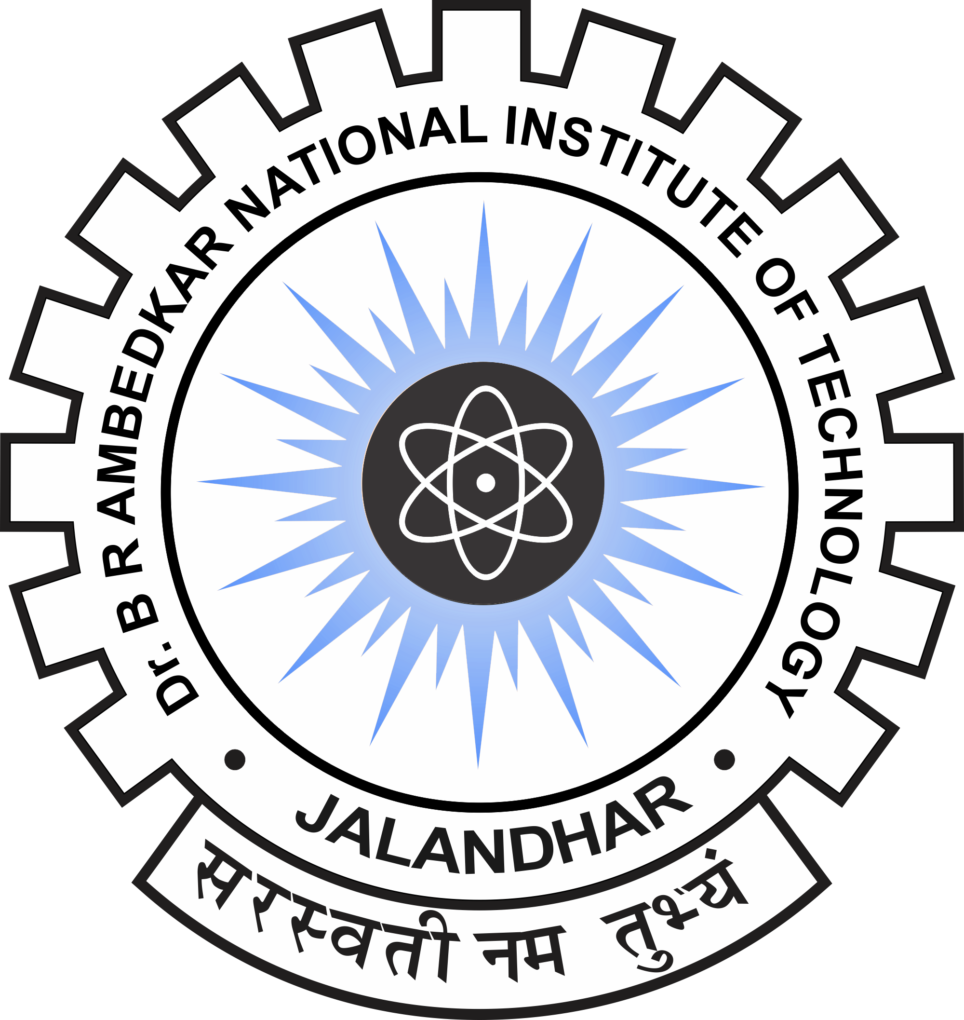

**Dr. B R Ambedkar National Institute of Technology, Jalandhar**

**Punjab- 144011**

**SUBMITTED TO : SUBMITTED BY :**

Dr. Nisha Chaurasa Arvinder Sngh

Assistant Professor 18124004

IT Department IT/4th Semester